Prediction of car accident severity

# Carlo Peano

# September 30, 2020

## 1. Introduction

### 1.1 Background

According to the WHO[1], even though vehicles have become much safer in the last decades, every year around 1.35 million people still die because of a road traffic crash and between 20 and 50 million more people suffer non-fatal injuries with many incurring a disability.

If we take a different perspective and consider the economic impact at national level, road traffic accidents also cost around 3% of gross domestic product to most countries[2].

Therefore, there is a great interest in different parts of society (such governments, decision-makers, carmakers, drivers, insurance companies) in changing and decreasing this trend.

### 1.2 Problem

A solution that would reduce the number of incidents could be the chance to warn a driver about the possibility of getting into a car accident and how severe that incident would be, given the weather and road conditions. In this way people would drive more carefully or even stay home.

Transforming this solution into a machine learning problem, I used a dataset provided by a city and its police department (in our case Seattle City and the SPD - Seattle Police Department) to predict the severity (and its probability) of an accident based on the conditions of weather, light and the road.

## 2. Data

### 2.1 Data understanding

In this project I used the data provided by the SPD (Seattle Police Department) and recorded by the Traffic Records. This dataset - called Data-Collisions.csv - includes all types of collisions involving cars, bikes, pedestrians and others (around 200,000) from 2004 to present.

After I extracted the dataset, I looked at the columns, their meaning and their relation to the objective of the research study, i.e. to predict the probability and severity of an accident based on the conditions of weather, light and the road.

Thanks also to the description of the attributes (available together with the dataset[3]), I have been able to define the attributes and the target variable. In my opinion, it was obvious to choose SEVERITYCODE (i.e. the severity of the accident) as the dependent variable. SEVERITYCODE is a categorical variable and follows a code that corresponds to the severity of the collision: 2 (injury) and 1 (property damage).

Out of the 37 attributes available in Seattle accident dataset, I chose 7 of them as independent variables, thanks – as previously said – to their logical connection to the objective of our research study.

|  |  |
| --- | --- |
| Variable | Description |
| JUNCTIONTYPE | Category of junction at which collision took place |
| WEATHER | A description of the weather conditions during the time of the collision |
| ROADCOND | The condition of the road during the collision |
| LIGHTCOND | The light conditions during the collision |
| SPEEDING | Whether or not speeding was a factor in the collision |
| PERSONCOUNT | The total number of people involved in the collision |
| VEHCOUNT | The number of vehicles involved in the collision. This is entered by the state |

Table 2.1.1 Variables and their description

JUNCTION, WEATHER, ROADCOND, and LIGHTCOND are the main attributes since they are directly connected to the project’s objective.

PERSONCOUNT and VEHCOUNT makes us understand how big the accident can be: an accident can involve a lot of vehicles and people and still have nobody injured or no property damage.

Lastly, SPEEDING has always been considered to have a direct impact on the probability of the collision and is the only attribute that is actually a choice of the driver.

### 2.2 Data Preparation

#### 2.2.1 Data cleaning

Once I chose the attributes and the target variable, I dropped the unnecessary columns and analysed more deeply the necessary ones.

At this point, there were several problems with the dataset.

Firstly, most the eight attributes had missing data because the SPD did not write all the data:

1. "SPEEDING" has 185340 missing data
2. "JUNCTIONTYPE" has 6329 missing data
3. "WEATHER" has 5081 missing data
4. "ROADCOND" has 5012 missing data
5. "LIGHTCOND" has 5170 missing data
6. "PERSONCOUNT" has 0 missing data
7. "VEHCOUNT" has 0 missing data

If most of the missing data were easily solvable by deleting them, those ones of SPEEDING seemed immediately problematic, as more than 90% of the data was missing. However, a direct observation of the attribute values showed that the police took in consideration this attribute – by writing “Y” – only when speed was one of the causes of the accident, otherwise they left the variable empty. As a consequence of this, I considered all the missing data as an “N”, i.e. speed was not one of the reasons of the incident.

Secondly, four attributes had data internally classified as “Other” and/or “Unknown” which were a sort of hidden missing data as they did not actually provide a real information about the attribute and could actually provide confusion:

1. "JUNCTIONTYPE" has 9 "Unknown"
2. "WEATHER" has 832 "Other" and 15091 "Unknown"
3. "ROADCOND" has 132 "Other" and 11012 "Unknown"
4. "LIGHTCOND" has 235 "Other" and 13473 "Unknown"

I used different methods for managing the two parameters. “Other” means that the data cannot be replaced by any other available observation, therefore it was replaced with NaN and its rows were dropped together with the missing data. “Unknown” was replaced with the mode of the related attribute so as to avoid biasing the dataset.

Thirdly, there was a problem with PERSONCOUNT (the total number of people involved in the collision) and VEHCOUNT (the number of vehicles involved in the collision): PERSONCOUNT had 5544 incidents involving nobody (zero people) and VEHCOUNT had 5085 accidents involving zero vehicles. These observations were not interesting for the project as its objective implies the involvement of people and vehicles, the lack of one or both of them could bias the dataset. Therefore, I drop those rows were PERSONCOUNT and VEHCOUNT were zero.

#### 2.2.2 Correct data format

Considering the data format of the chosen attribute (see Table 2. Data format), I did not need to change any of them.

|  |  |
| --- | --- |
| Attribute | Type |
| SEVERITYCODE | int64 |
| PERSONCOUNT | int64 |
| VEHCOUNT | int64 |
| JUNCTIONTYPE | object |
| WEATHER | object |
| ROADCOND | object |
| LIGHTCOND | object |
| SPEEDING | int64 |

Table 2.2.2.1 Data format

#### 2.2.3 Feature selection

In order to balance the dataset, I used one hot encoding technique to convert categorical variables to binary variables and append them to the feature Data Frame. Then I defined the feature set X and the labels y and normalise the data.

## 3. Exploratory Data Analysis (Methodology – part 1)

#### 3.1 Relation between speeding and accidents

| **Speeding** | **Number of accidents** | **% of accidents** |
| --- | --- | --- |
| No | 167476 | 94.83% |
| Yes | 9122 | 5.17% |

Table 3.1 Relation between speeding and accidents

When I examined the value counts of speeding and considered what incidents speeding had on accidents, I saw that this attribute would not be a good predictor variable for the probability and severity of the accident. This is because only 5.17% of the accidents are caused by driving too fast: this result is skewed. Thus, we are not able to draw any conclusions about this attribute.

#### 3.2 Relation between the type of junction and accidents

Accidents happen in junctions as crossing one of them puts the drivers in a more stressful situation. Comparing the different types of junctions, I discovered that most of the accidents (47,16%) take place in mid-block crossing that are not related to intersections.

| **Type of junction** | **Number of accidents** | **% of accidents** |
| --- | --- | --- |
| Mid-Block (not related to intersection) | 83286 | 47.16 % |
| At Intersection (intersection related) | 59106 | 33.47 % |
| Mid-Block (but intersection related) | 21890 | 12.40 % |
| Driveway Junction | 10215 | 5.78 % |
| At Intersection (but not related to intersection) | 1944 | 1.10 % |
| Ramp Junction | 157 | 0.09 % |

Table 3.2.1 Relation between the type of junction and accidents

Accidents at intersections (related to the intersection) are the second most often incidents (33.47%) and happen more than the double of the time that the incidents in mid-block crossing related to intersections (12.40%).

The first three types of junction together are the places where more of the accidents happen (more than 90%), and this is evident if we look at the diagram below (diagram 3.2.1).

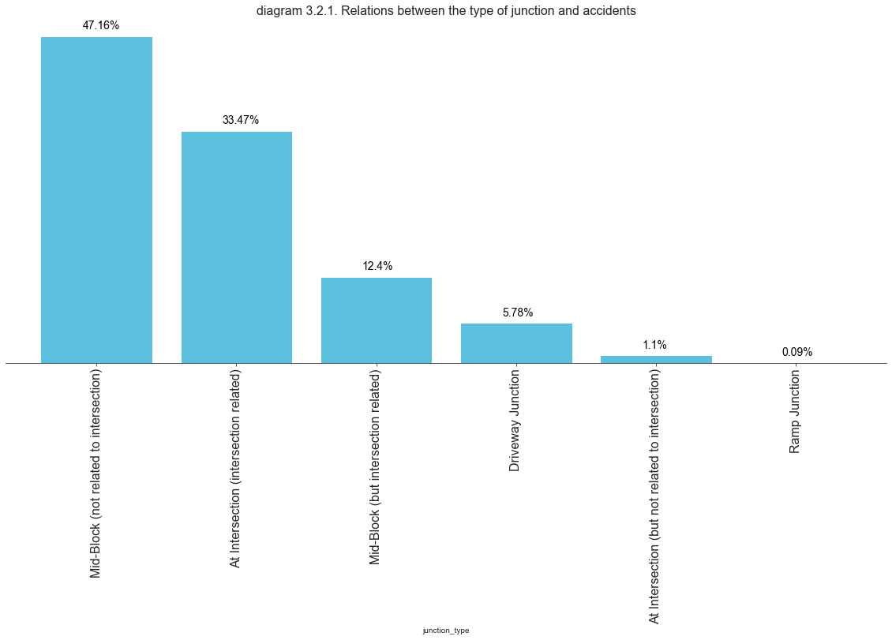

Considering the kind of severity that the incident can have, accidents with property damages are always more often than those ones with injuries.

| **Type of junction** | **Severity (1 = property damage, 2 = injury)** | **Number of accidents** |
| --- | --- | --- |
| At Intersection (but not related to intersection) | 1 | 1365 |
| 2 | 579 |
| At Intersection (intersection related) | 1 | 33337 |
| 2 | 25769 |
| Driveway Junction | 1 | 7105 |
| 2 | 3110 |
| Mid-Block (but intersection related) | 1 | 14838 |
| 2 | 7052 |
| Mid-Block (not related to intersection) | 1 | 65293 |
| 2 | 17993 |
| Ramp Junction | 1 | 107 |
| 2 | 50 |

Table 3.2.2 Relation between the type of junction and the severity of the accidents (1 = property damage, 2 = injury)

The majority of the accidents takes place in mid-block crossings (not related to intersections), which have the highest number of incidents with property damages (i.e. 65,293): a number higher than the sum of incidents with property damages in the other junctions.

However, even though the accidents with injuries in mid-block crossings (not related to intersections) is still high (i.e. 17,993), it is smaller than the incidents with injuries at intersections (i.e. 25.769).

Incidents at intersections (related to intersections) are the accidents with the higher number of injuries (i.e. 25,769) and this makes them the most dangerous junctions if we consider the safety of the people.

These observations are evident if we look at the diagram 3.2.2, that shows the relations between the severity of the accidents and the type of junctions.

Diagram 3.2.2. Severity of the accidents and type of junction

#### 3.3 Relation between the weather and accidents

Weather is another variable that can influence the driver and create conditions that increase the difficulty of driving.

Even though we may think that severe crosswind, hail, snow or fog are the main causes of the accidents, this is actually not true.

| **Weather** | **Number of accidents** | **% of accidents** |
| --- | --- | --- |
| Clear | 116714 | 66.09 |
| Raining | 31793 | 18.00 |
| Overcast | 26509 | 15.01 |
| Snowing | 865 | 0.49 |
| Fog/Smog/Smoke | 533 | 0.30 |
| Sleet/Hail/Freezing Rain | 106 | 0.06 |
| Blowing Sand/Dirt | 48 | 0.03 |
| Severe Crosswind | 25 | 0.01 |
| Partly Cloudy | 5 | 0.00 |

Table 3.3.1 Relation between the weather and accidents

The majority of the accidents take place with clear weather (66.09%), rain (18%) and overcast (15.01%) and together they are the 99.10% of all the incidents.

| **Weather** | **Severity (1 = property damage, 2 = injury)** | **Number of accidents** |
| --- | --- | --- |
| Blowing Sand/Dirt | 1 | 36 |
| 2 | 12 |
| Clear | 1 | 81758 |
| 2 | 34956 |
| Fog/Smog/Smoke | 1 | 357 |
| 2 | 176 |
| Overcast | 1 | 18074 |
| 2 | 8435 |
| Partly Cloudy | 1 | 2 |
| 2 | 3 |
| Raining | 1 | 21017 |
| 2 | 10776 |
| Severe Crosswind | 1 | 18 |
| 2 | 7 |
| Sleet/Hail/Freezing Rain | 1 | 79 |
| 2 | 27 |
| Snowing | 1 | 704 |
| 2 | 161 |

Table 3.3.2 Relation between the weather and severity of the accidents

Like in the case of the junctions, the weather always has more incidents with property damages than with injuries. The diagram below (Diagram 3.3.1) shows even better how the majority of the accidents – both with property damages and injuries – occurs with clear sky.

Diagram 3.3.1 Relation between weather and the type of severity (1 = property damage, 2 = injury)

#### 3.4 Relation between the road conditions and accidents

Road conditions as well have an impact on the accidents and their severity as they may put the driver in complicated and stressful situations. Circumstances where the road has ice, snow, oil or water are dangerous and may not be properly managed.

| **Road conditions** | **Number of accidents** | **% of accidents** |
| --- | --- | --- |
| Dry | 128735 | 72.90 |
| Wet | 45538 | 25.79 |
| Ice | 1143 | 0.65 |
| Snow/Slush | 956 | 0.54 |
| Standing Water | 103 | 0.06 |
| Sand/Mud/Dirt | 65 | 0.04 |
| Oil | 58 | 0.03 |

Table 3.4.1 Relation between the road condition and accidents

Surprisingly, the vast majority of the accidents take place when the roads are dry, in the 72.90% of the cases. Wet conditions of the road are the variable with the second higher percentage of incident (25.79%).

These two variables together collect the 98.69% of the accidents while the other apparently more complicated conditions are correlated to only 1.31%.

| **Road conditions** | **Severity (1 = property damage, 2 = injury)** | **Number of accidents** |
| --- | --- | --- |
| Dry | 1 | 89879 |
| 2 | 38856 |
| Ice | 1 | 888 |
| 2 | 255 |
| Oil | 1 | 34 |
| 2 | 24 |
| Sand/Mud/Dirt | 1 | 43 |
| 2 | 22 |
| Snow/Slush | 1 | 795 |
| 2 | 161 |
| Standing Water | 1 | 77 |
| 2 | 26 |
| Wet | 1 | 30329 |
| 2 | 15209 |

Table 3.4.2 Relation between the road conditions and the severity of the accidents (1 = property damage, 2 = injury)

Like with other previous attributes, road condition always has more incidents with property damages than with injuries. The diagram below (Diagram 3.4.1) makes even more visible how the majority of the accidents – both with property damages and injuries – occurs with dry conditions of the road.

Diagram 3.4.1 Relation between road conditions and the type of severity (1 = property damage, 2 = injury)

#### 3.5 Relation between the light conditions and accidents

Light conditions have an impact on the accidents and their severity. Situations like driving in the dark with no street lights may be dangerous and stressful for a driver.

| **Light conditions** | **Number of accidents** | **% of accidents** |  |
| --- | --- | --- | --- |
| Daylight | 119798 | 67.84 |  |
| Dark - Street Lights On | 46296 | 26.22 |  |
| Dusk | 5599 | 3.17 |  |
| Dawn | 2360 | 1.34 |  |
| Dark - No Street Lights | 1407 | 0.80 |  |
| Dark - Street Lights Off | 1129 | 0.64 |  |
| Dark - Unknown Lighting | 9 | 0.01 |  |

Table 3.5.1 Relation between the light condition and accidents

However, the vast majority of the accidents does not take place in the dark, or during the dusk or dawn, but in daylight (in 67.84% of the cases). Dark with lights street on is the variable with the second higher percentage of incident (26.22%). Together they cover the 94.06% of the accidents.

| **Road conditions** | **Severity (1 = property damage, 2 = injury)** | **Number of accidents** |
| --- | --- | --- |
| Dark - No Street Lights | 1 | 1096 |
| 2 | 311 |
| Dark - Street Lights Off | 1 | 821 |
| 2 | 308 |
| Dark - Street Lights On | 1 | 32346 |
| 2 | 13950 |
| Dark - Unknown Lighting | 1 | 6 |
| 2 | 3 |
| Dawn | 1 | 1576 |
| 2 | 784 |
| Daylight | 1 | 82461 |
| 2 | 37337 |
| Dusk | 1 | 3739 |
| 2 | 1860 |

Table 3.5.2 Relation between the light conditions and the severity of the accidents (1 = property damage, 2 = injury)

Like in other previous attributes, light condition always has more accidents with property damages than with injuries. The diagram below (Diagram 3.5.1) shows how the majority of the accidents – both with property damages and injuries – occurs in daylight and darkness (with street lights on), the proportions between them and the other conditions.

Diagram 3.5.1 Relation between light conditions and the type of severity (1 = property damage, 2 = injury)

#### 3.6 Relation between accidents and people involved

The number of people involved in an accident is another attribute to take in consideration. Its mean per accident is 2.55 people, its mode is 2 and the 75% of the data are between 1 and 3 people. This means that even though the highest number of people involved in an accident is 81 people, the vast majority of the incidents involve very few people.

| **People involved** | **% of accidents** |
| --- | --- |
| 2 | 59.48 |
| 3 | 19.67 |
| 4 | 8.10 |
| 1 | 6.27 |
| 5 | 3.70 |
| 6 | 1.52 |
| 7 | 0.63 |
| 8 | 0.30 |
| 9 | 0.12 |
| 10 | 0.07 |

Table 3.6.1 Relation between accidents and people involved

The majority of the accidents involves 2 people (59.48%). Incidents involving 3 people have the second higher percentage (19.67%). Together they cover 79.15% of the accidents and the percentage increase to 98,74% if we consider all the incidents that involve from 1 to 6 people. Over 10 people the percentage of the accidents becomes so small that is rounded to zero.

This is even more visible in the diagram below (3.6.1) that shows how accidents (both with property damages and injuries) involve a very small number of people for most of the times and the rest of the cases is mainly composed by outliers.

Diagram 3.6.1 Relation between people involved and the type of severity (1 = property damage, 2 = injury)

#### 3.7 Relation between accidents and vehicles involved

The number of vehicles involved in incidents is the last attribute that I took in consideration. Its mean per accident is 1.97 vehicles, its mode is 2 and the 75% of the accidents involve 1 or 2 vehicles. This means that even though the highest number of vehicles involved in an accident is 12 people, the vast majority of the incidents involve very few vehicles – as it is visible in the diagram below (diagram 3.7.1).

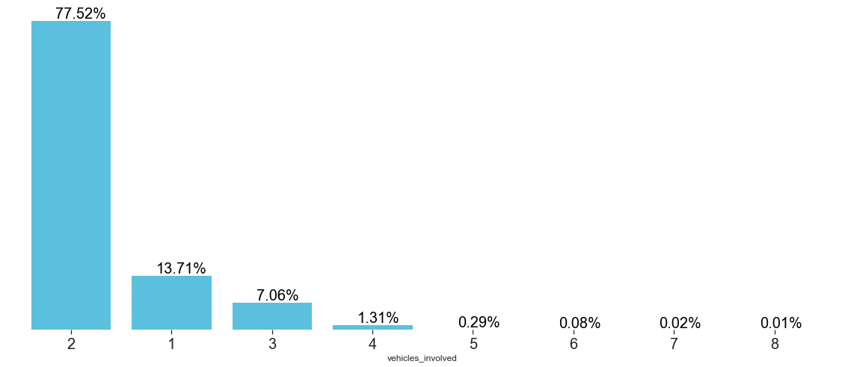

Diagram 3.7.1 Percentage of vehicles involved in accidents

The 91.23% of the accidents involves 1 or 2 vehicles and the 98.29% involves between 1 and 3 vehicles. Over the 8 vehicles the percentage is so low that is rounded to zero.

Therefore, both the severities (i.e. property damages and injuries) are focus on the accidents that involve 2 vehicles – as shown in the diagram below (diagram 3.7.2) – and the rest of the cases is mainly composed by outliers.

Diagram 3.7.2 Relation between vehicles involved and the type of severity (1 = property damage, 2 = injury)

**4. Predictive Modelling (Methodology – part 2)**

As the target (i.e. dependent variable) is a categorical data, the logical model to is classification as to predict the severity of an accident.

The application of classification models follows a specific path. I divided the samples into two classes (80% training data, 20% test data, giving a random state of 4).

I then used three techniques to create three different predictive models:

1. Decision Tree
2. Support Vector Machine (SVM)
3. Logistic Regression.

Among the three models, logistic regression was the one that had the lowest accuracy with all the methodologies that I used, as it is evident from Table 4.1.

| **Algorithm** | **Jaccard** | **F1-score** | **Accuracy** | **LogLoss** |
| --- | --- | --- | --- | --- |
| Decision Tree | 0.7171 | 0.6953 | 0.7396 | NA |
| SVM | 0.7216 | 0.6828 | 0.7395 | NA |
| Logistic Regression | 0.6984 | 0.6640 | 0.7171 | 0.5775 |

Table 4.1 Performance of classification models - Accuracy (red best results)

Even though the decision tree has a lower Jaccard score than the one of SVM, its F1-score and the accuracy (using metrics.accuracy_score) are slightly higher. This situation is well shown by their confusion matrixes as it is possible to see in the diagrams below (Diagram 4.1, 4.2, 4.3).

Diagram 4.1 Confusion matrix – Decision Tree (1 = injuries; 2 = property damages)

Diagram 4.2 Confusion matrix – SVM (1 = injuries; 2 = property damages)

Diagram 4.3 Confusion matrix – Logistic Regression (1 = injuries; 2 = property damages)

The three confusion matrixes show how the logistic regression model has a higher mistake with both severity 1 (i.e. injuries) and 2 (i.e. property damages). However, the decision tree has the lowest false negative while the SVM the lowest false positive (see table below, Table 4.2).

| **Algorithm** | **True Positives** | **False Positives** | **False Negatives** | **True Negatives** |
| --- | --- | --- | --- | --- |
| Decision Tree | 23,331 | 1,182 | 8,017 | 2,800 |
| SVM | 23,847 | 656 | 8,544 | 2,273 |
| Logistic Regression | 23,135 | 1,368 | 8,624 | 2,193 |

Table 4.2 Performance of classification models – True/False Positive/Negative (red best results)

In this situation, both the decision tree and the SVM are good models to use.

If we consider the objective of our project – i.e. predicting the severity (and its probability) of an accident based on the conditions of weather, light and the road – predicting injuries (i.e. 1) is more important than property damages (i.e. 2).

Therefore, the Support Vector Machine is the best model to use, as it has higher true positives, thus it predicts accidents with injuries with greater accuracy.

## 5. Results

Data --> more accidents with better conditions

…

Regarding the If we consider the objective of our project – i.e. predicting the severity (and its probability) of an accident based on the conditions of weather, light and the road – predicting injuries (i.e. 1) is more important than property damages (i.e. 2).

Therefore, the Support Vector Machine is the best model to use, as it has higher true positives, thus it predicts accidents with injuries with greater accuracy.

## 6. Discussion

Any recommendation based on the results

## 7.Conclusion

## 8. Future directions

1. "Road traffic injuries", World Health Organisation (WHO), 07/02/2020, <https://www.who.int/news-room/fact-sheets/detail/road-traffic-injuries>
2. Ibid.
3. "ArcGIS Metadata Form", <https://s3.us.cloud-object-storage.appdomain.cloud/cf-courses-data/CognitiveClass/DP0701EN/version-2/Metadata.pdf>